**Request for Social Media Promotion – Fundraising Groups**

With more of our Fundraising Groups having a social media presence we want to be able to help you to promote your events and activities. We have access to do this through CANVA and will try and use similar formats for all requests to help it look and feel like a Marie Curie Fundraising Group event.

An example can be found here:

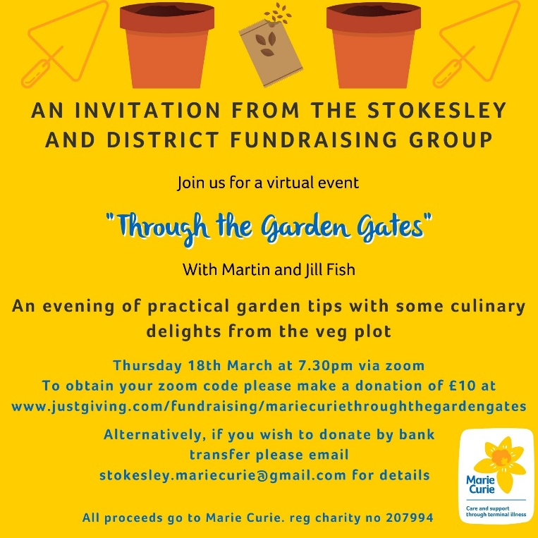

Your Fundraising Group can make a request by completing the form below. Please include as much information as possible and send it to us with as much notice as possible, at least 5 working days. Please email your form to [frvolunteering@mariecurie.org.uk](mailto:frvolunteering@mariecurie.org.uk) and include your community fundraiser in the email.

|  |  |
| --- | --- |
| **Fundraising Group Name:** |  |
| **Name of the Event:** |  |
| **Date and Time:** |  |
| **Event information (details, joining/sign up instructions):** |  |
| **Preference on images (similar to plant pots in example):** |  |
| **Format Preference:** | JPG or PDF |
| **Where will you be using it? (we can make different formats for different social media):** | Twitter/Facebook/email invite/flyer |