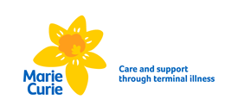s

Working together with kindness, care and commitment to create a community which values everyone



**Care and support**

**through terminal illness**

[](https://www.google.co.uk/imgres?imgurl=https%3A%2F%2Fcarwad.net%2Fsites%2Fdefault%2Ffiles%2Fcartoon-daffodil-104544-5380720.jpg&imgrefurl=https%3A%2F%2Fcarwad.net%2Fwallpaper-266283&docid=9ByhKDBqPGhYNM&tbnid=rQPViWyfT4JalM%3A&vet=10ahUKEwjg_Z_a0-jhAhVR8OAKHdO6Av4QMwiaASg-MD4..i&w=260&h=300&bih=884&biw=1242&q=daffodil%20images&ved=0ahUKEwjg_Z_a0-jhAhVR8OAKHdO6Av4QMwiaASg-MD4&iact=mrc&uact=8)

**Care and support**

**through terminal illness**

**People at our heart**

Improve and increase carers’ support

Community engagement

Improve our environment and access

Expand and extend our services

Develop our workforce

A thriving centre